Comparing Stochastic and Deterministic Solutions

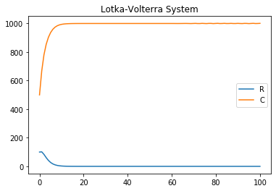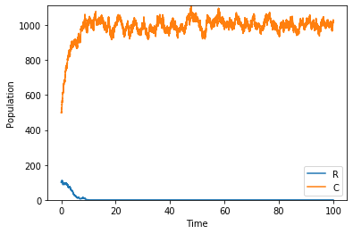

On the left we have the plot for the deterministic form of the Lotka-Volterra system, while on the right is a display of the stochastic form’s output using the Gillespie algorithm. Both of these systems are plotted between a time of 0 and 100, with populations of the resident and challenger being 100 and 500 respectively. The carrying capacity is 1000 for both populations. The competitions terms for the resident and challenger are 1.5 and 1.3 respectively.

We can see that the noise in the stochastic plot matches the general shape of the curves in the deterministic plot. The noise itself can be attributed to the tau leaping method of obtaining stochastic solutions. Jumps in population size are pronounced due to the fact that each change can only be an integer i.e. we cannot have a change of 0.5. So, we have an output in which the transitions between population sizes is discrete as opposed to the ODE version, where it is continuous.

The resident population appears to die off relatively fast just before 10 (units?). Meanwhile the challenger sees an increase in its population up to the carrying capacity at which point it levels off at the carrying capacity. However, upon inspecting the SDE plot we can see this is not the case, and there are in fact constant changes the population size many of which go above the carrying capacity.

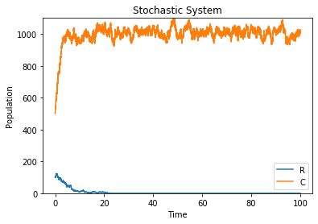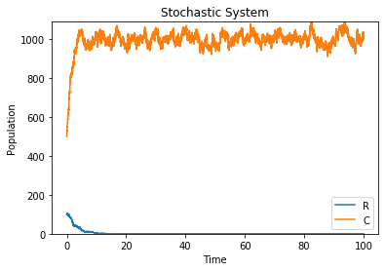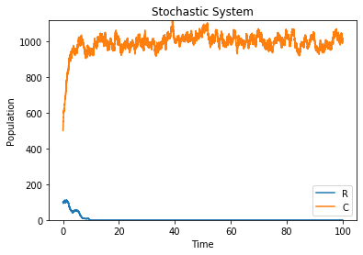Due to the stochastic nature of the Gillespie algorithm, there is no determinism in the solution. Each time a run is generated, a new value for the population size is drawn from a Poisson process. Thus, each simulation will look slightly different from the previous.

The most obvious changes in each plot can be seen at the beginning of the resident population but there are still significant fluctuations in the challenger population often peaking above the K value.

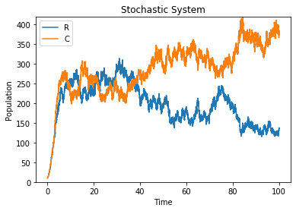

The plot is above was run with very small population sizes (10) and competition terms of 1. The two trajectories intersect at several points, where the two strains are competing. At these low population sizes there appears to be greater noise compared to the higher sizes.

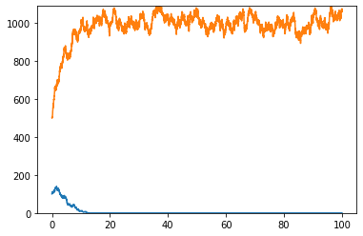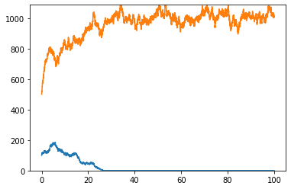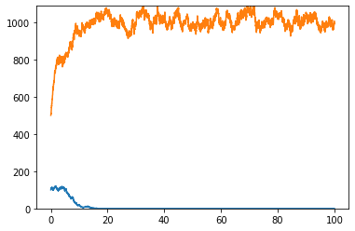The tau leaping method projects solutions for the stochastic form faster than the Gillespie algorithm however there are slight variations in the shape of the former compared to the latter. For example, there appears to be some curvature as the population size starts to tend towards the carrying capacity.

One thing that is noteworthy of this approach is the effect of the value of tau on the noise. A smaller value chosen for tau causes much greater noise than a higher value. For example, a tau of 0.001 compared with a tau of 1.

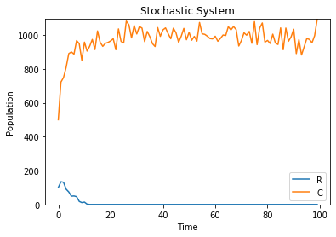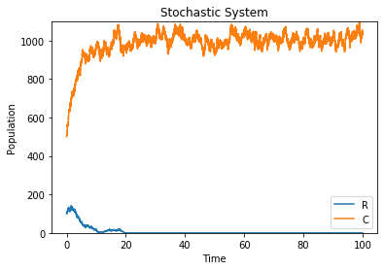

In terms of running these in python, the smaller the value of tau, the longer the program takes to run.